ST. HENRYS COLLEGE NAMUGONGO – KAMPALA

END OF TERM TWO EXAMINATIONS - 2024

MATHEMATICS paper 1 (456/1) for S.3

Duration : 2Hours : 15 Minutes

INSTRUCTIONS:



1

SECTION A:

This contains patterns and algebra where the two numbers set are compulsory to the candidate

ITEM. 1.

The Prime Minister for Buganda Kingdom visited Mityana S.S and appreciated efforts put in

1

project work by the agriculture department. He noted that

7

8 of the school farm is used for

banana plantations, ¼ for cattle keeping and

10 of the remainder for multi-purpose projects.

This leaves 9 acres of the school land untouched.

The school has teaching staff of 180 teachers of which

2

1

3 of the male staff teach science

subjects and

5 of the emale staff teach Art subjects and 112 teach other subjects.

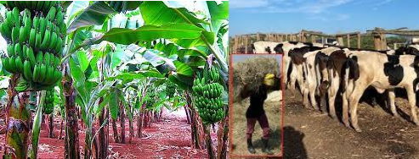

Task;

(a) Which fraction of land is used for multipurpose projects

(b) (i) How many acres of land does the school have

(ii) Use a clear diagram to partition the land?

(c) Find the percentage of female teacher who teach Art subjects

ITEM 2.

A tailor is planning to design a budge ABC in triangular shape basing on the X –Y plane such that A is 3 cm in the north of the origin, line segment AB has x - intercept of -2 whereas the x- intercept of line segment AC is 4.

Task;

(a). Help the tailor to come up with the accurate design

(b). How many budges can the tailor make from a material of area 0.225m2 . (c ). Deduce inequalities satisfying the region covered by one accurate budge.

***SECTION B (I)***

This contains data collection and probability from which a candidate picks 1 number out of the 2

ITEM 3.

In 2020, schools closed, the economy was shut down and many people got infected of which some died.

The Covid 19 pandemic made us to loose 35% people in East Africa, 30% in the central

Africa, 15% in the West Africa and 120 people in the northern Africa.

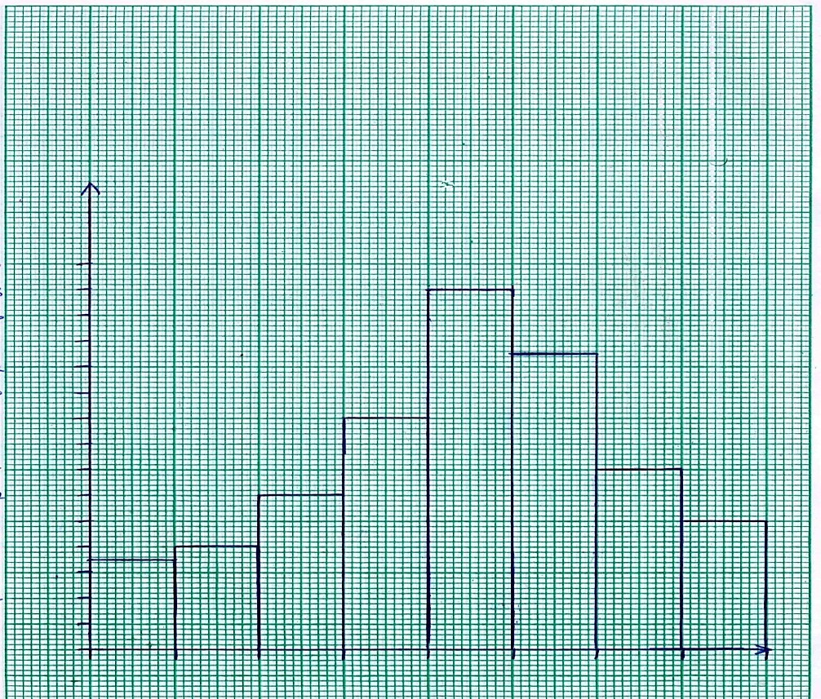

5

The horizontal axis starts at 19.5kg and has a width of 10kg. The vertical axis starts at 0 and

has a scale of 1cm : 2 people.

Task:

(a) As the head of ministry of health in one of the African countries, which suitable method would you use to present the death rate to the W. H .O and how would you advise the entire continent?

(b) Use the graph above to estimate the modal weight of those who survived. (c) What was the average weight of the group that survived?

ITEM 4.

The government wants to improve the lively hood of people in your community by buying them goats, cows or sheep but it doesn’t know the exact number of animals to buy and which animals to buy in larger quantities for the first phase of the project. a group of people were sampled for the first phase of the project, among them 50 denied the idea because they didn’t have space to

keep any of the animals,30choose to keep goats only, those who chose to keep only sheep were half of those who chose to keep only goats and five more than those who chose to keep only cattle.38 chose to keep both cattle and goats, 58 choose to keep both cattle and sheep, 30 could keep both goats and sheep. 80 people all together accepted to keep goats.

Task;

a) Determine the number of people who were sampled

b) Calculate the chance that a person selected from the sample keeps at least two

c. How many people choose one type of animals?

SECTION B (II)

This contains geometry and measurements from which a candidate picks 1number out of the 2

Item 5



ITEM 6.

A company selling newspapers spends shs.1450 to produce a copy of news paper and sells it at shs. 2500.

On a certain day, the company produced 3200 copies and managed to sell 1500 copies only hence making a loss.

This left the manager wondering on what should be done to maximize profits.

He later realized that there was need to closely monitor production costs, widen the market base and buy more 4 vehicles of (Toyota Land Cruiser) to improve on transport.

He went to the bank and was given a loan of 900 millions at a compound interest rate of 8% per annum.

He then visited spear motor and bought 4 vehicles on cash basing on the advert below.

Toyota Land Cruiser on sale!!!!!!

|  |  |  |  |  |  |  |
| --- | --- | --- | --- | --- | --- | --- |
|  | |  | | |  | |
|  |  |
|  |  |  |  |
|  |  |
|  | |  | |

Marked price shs. 250,000,000

Cash price shs. 21% less than marked price

Hire purchase terms, Deposit 18 million and pay

24 millions per month for 8 months

Task

(a). Determine the percentage loss the company made

(b).(i) Which amount did the company pay to the bank after 3 years.

(ii). How can a loan benefit you as a business person?

(c). How much money did the manager save for the company after buying 4 Land Cruisers on cash rather than on hire purchase terms?

(d). which strategies should the company apply to maximize profits?

End